Pipeline creation
Docker – install Jenkins
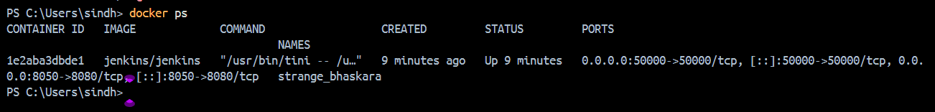
Maven installed
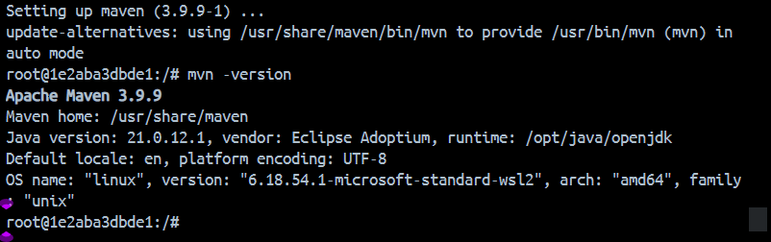
Inside Jenkins multibranch pipeline
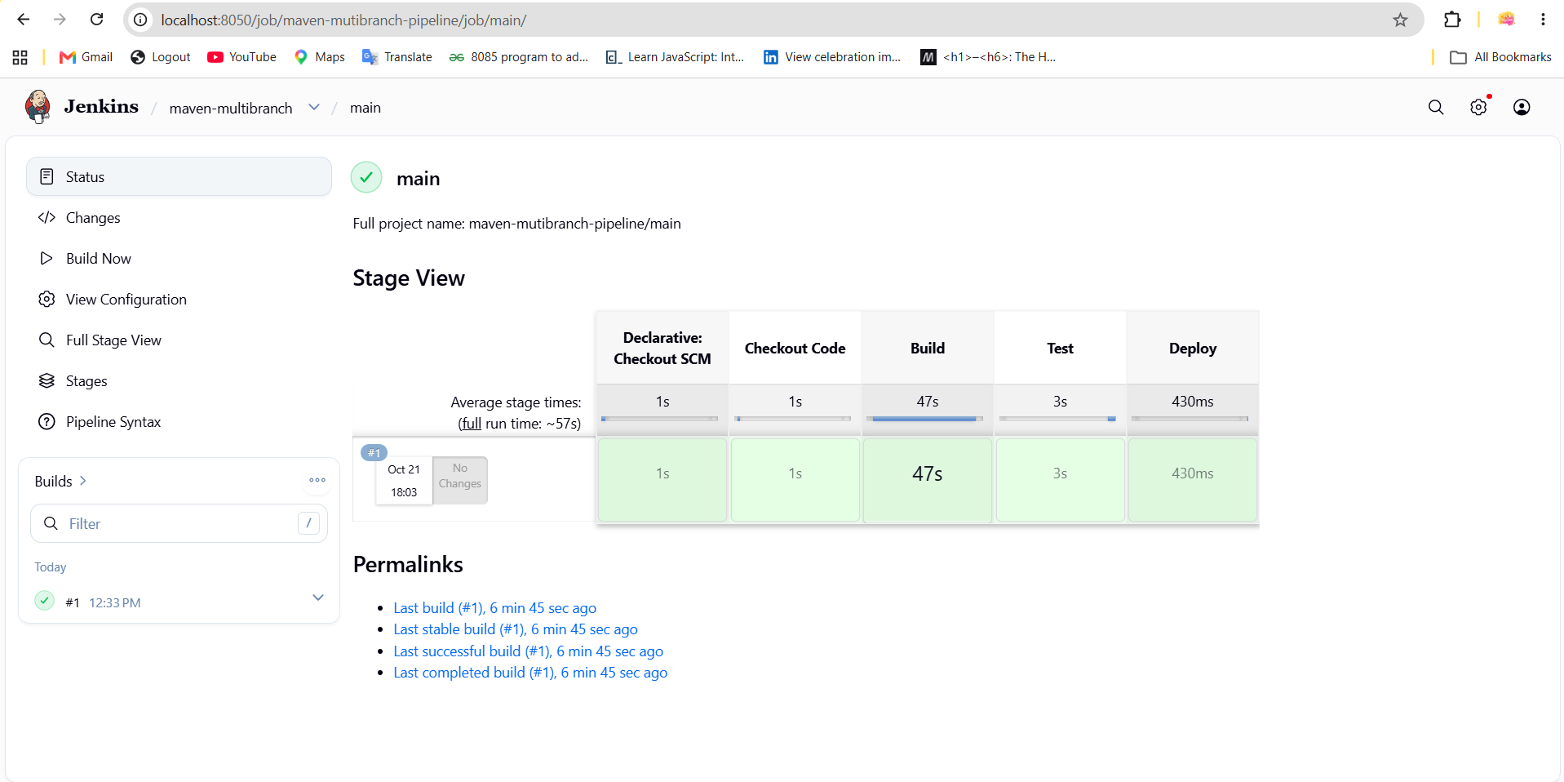

Before creating a branch
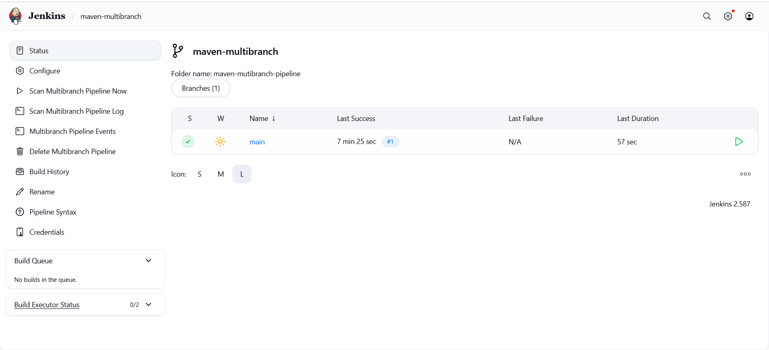
A new branch Sivaranjani is created and a pipeline for it
